

Health and Usage Monitoring System (HUMS) Program Manual

IMPORTANT

THE GPMS HUMS PROGRAM MANUAL IS INTENDED TO PROVIDE OPERATORS WITH A TEMPLATE FOR BUILDING A HUMS PROGRAM TAILORED TO THEIR SPECIFIC OPERATIONAL REQUIREMENTS. THE PROCESSES HEREIN ARE FOR EXAMPLE PURPOSES ONLY. ANY REQUIEMENTS OR RESTRICTIONS IMPLIMENTED ARE AT THE OPERATOR'S DISCRETION.

REVISION CONTROL

Revision | Date | Approved By | Description
I |  |  | Initial Issue

Table of Contents
Preface
Title Page 1
Revision Record 2
Table of Contents 3

1. Revision Control
Revision Control Policy 4

2. Introduction
Introduction 4

3. Equipment and Functionality
1. Mechanical Diagnostics/Vibration Monitoring 5
2. Rotor Track and Balance 5
3. Flight Data Monitoring 5
4. Engine Performance Monitoring 6

4. Program Responsibilities
1. HUMS Program Manager 6
2. HUMS Steering Committee 7
3. Line Technicians 7

5. Training
1. Line Technician 7
2. HUMS Program Manager 7

6. Process
1. Data Collection 7
2. Data Review 8
3. Data Analysis 8
4. Risk Analysis 10
5. Close Monitoring 11
6. Inoperative Equipment 12
7. Reports 12

7. HUMS Action Matrix
1. HUMS Alert Definitions 14
2. Action Matrix Definitions 14
3. Failure Mode Index 15

Appendix A
HUMS Alert Log 16

Appendix B
HUMS Action Matrix 17

Appendix C
HUMS Flow Chart 18

1. Revision Control

The ENTER COMPANY HUMS Program Manual document ENTER DOC NUMBER will utilize a numerical revision number to indicate its version.

Changes to this manual are made as required to ensure the ENTER COMPANY HUMS program continues to meet company and stakeholder objectives. The ENTER TITLE shall approve all changes.

The ENTER TITLE is responsible for ensuring changes are incorporated and that the revised version is made available to the appropriate personnel.

The revision record in the preface of this document shall list the revision number, revision date, person approving the revision, and a description of the changes, including affected page numbers. Except for a reissue, changes will also be indicated by a revision bar in the left-hand column adjacent to the revised section/paragraph.

All company personnel are responsible for ensuring printed copies of the manual are of the latest revision prior to following the procedures therein.

2. Introduction

Health and Usage Monitoring Systems (HUMS) are designed to automatically monitor the health of the aircraft and its dynamic components. The term “health” refers to the overall condition of the aircraft, assessed using modalities developed through well-established science and engineering, along with aviation industry best practices and objectives.

Procedures established in the CAA-approved maintenance program shall determine the aircraft's airworthiness and the serviceability of its components. The ENTER COMPANY HUMS Program is intended to supplement the existing maintenance program by improving safety and providing additional insights to help make informed decisions about maintenance and aircraft dispatch.

The primary source of aircraft health information comes from the measurement, processing, and analysis of the vibratory behaviors of dynamic mechanical components. Vibration sensors are used to detect abnormal conditions and trends that coincide with mechanical degradation. Thresholding tools are used to indicate significant statistical deviation from “normal” behaviors or conditions. Some thresholds are based on physical limits established by the OEM, but often no such limits exist; therefore, the decision-making process for HUMS findings is effectively a risk-management strategy rather than one of regulatory compliance.

Parametric (flight) data monitoring utilizes an interface with aircraft instruments to record flight data and report operational exceedances of OEM- or Operator-defined limits.

Another critical factor in safe and reliable aircraft operations is the performance of the aircraft’s engine(s) and their ability to generate rated power. Trends in engine power degradation, as measured by a HUMS, can trigger preventive maintenance actions and avoid unscheduled operational interruptions.

3. Equipment and Functionality

The specific functionality of a HUMS system may vary depending on the manufacturer and the scope of the design. The ENTER COMPANY HUMS Program requires the following minimum capabilities.

- Mechanical Diagnostics/Vibration Monitoring

  - The system shall include sensors (accelerometers and tachometers) capable of recording vibration data for all critical rotating components, including the main and tail gearboxes, engines, hanger bearings, and driveshafts.
  - The system shall employ the following minimum condition indicators (CIs).
    - Shafts
      - SO1 (1/rev imbalance)
      - SO2 (2/rev imbalance)
    - Bearings
      - Cage Energy
      - Ball/Roller Energy
      - Inner/Outer Race Energy
    - Gears
      - Residual RMS
      - EO Kurtosis
      - AM RMS
      - AM Residual RMS
      - FM Kurtosis
  - The system shall provide a method of thresholding that will alert the company to abnormal vibration/behaviors.
  - Thresholds must be adjustable based on established limits, findings, and other supporting data.

- Rotor Track and Balance

  - The system shall include sensors (accelerometers and tachometers) capable of recording Main and Tail Rotor 1/rev vibration magnitude and phase, and provide solutions for correcting track and balance discrepancies.

- Flight Data Monitoring

  - The system shall provide a method of recording aircraft instrumentation data and generating alerts for operational profile/performance warnings and exceedances.
  - The system shall record and provide exceedance notifications for the following parameters:

    - NR
    - N2
    - N1
    - Torque
    - Engine Temperature
    - IAS
    - Pres Altitude
    - Alt Rate
    - Pitch/Pitch Rate
    - Roll/Roll Rate
    - Yaw Rate
    - Z/Vertical Acceleration
    - Heading
    - OAT

- Engine Performance Monitoring

  - The system shall provide a method of recording the engine power rating and generating alerts for engine performance degradation.

4. Program Responsibilities

The following will define the roles are responsibilities for the ENTER COMPANY HUMS Program functions.

- HUMS Program Manager

  - The ENTER TITLE is responsible for the implementation and management of the ENTER COMPANY HUMS Program.
  - The responsibilities of the HUMS Program include, but are not limited to:
    - Developing and enforcing procedures for achieving HUMS Program objectives.
    - Monitoring the proficiency of personnel assigned HUMS-related tasks and providing or arranging training when necessary.
    - Monitoring HUMS data to ensure systems are functional and that alerts are reported and analyzed.
    - Providing/supporting analysis of HUMS data to determine validity and impact.
    - Compiling case histories and reports for review by HUMS Steering Committee (see section 4.2).
- HUMS Steering Committee

  - The HUMS steering committee will provide a forum for risk analysis and decision-making regarding HUMS findings, post-incident review, and program changes.
  - The committee shall include the following personnel or their delegates:
    - HUMS Program Manager
    - Director of Maintenance
    - Director of Operations
    - Safety Manager
  - Risk-based decisions shall utilize the HUMS Risk Matrix (see Appendix B) and be documented via an internal company memo.

- Line Technicians

  - The Line Technician’s responsibilities include, but are not limited to:
    - Downloading HUMS data/verifying automated data transfers are successful.
    - Completing the HUMS Alert Log (see section 6.7 and Appendix A).
    - Reporting HUMS alerts to the HUMS Program Manager.
    - Carrying out inspections to validate HUMS indications.
    - Maintaining the HUMS equipment in accordance with the ICA/OEM requirements.

5. Training

The ENTER TITLE is responsible for ensuring all company personnel have the appropriate training for their respective responsibilities. Minimum requirements are outlined below.

- Line Technician – Shall attend an initial and a 2-year recurrent HUMS training course provided/endorsed by the aircraft or HUMS OEM.

- HUMS Program Manager – Shall attend an initial and a 2-year recurrent HUMS training course provided/endorsed by the aircraft or HUMS OEM, as well as a SMS or aviation risk management course.

6. Process

The following processes establish the required tasks and compliance intervals for most scenarios. If a finding or process issue arises that is not covered in these procedures, contact the HUMS Program Manager to determine the appropriate course of action.

- Data collection

  - Refer to the HUMS provider/OEM manual for download instructions.
  - Data shall be downloaded from the aircraft at least once per flight day. If the data is being transmitted automatically, verify that all data from each flight day has been uploaded successfully.
  - If the aircraft is away from the main base, without download capabilities, it may be deferred up to 15 flight hours.
  - The download interval shall not be extended if there is a component under Close Monitor (see section 6.5) without approval from the HUMS Program Manager.

- Data Review

  - Refer to the HUMS provider/OEM manual for instructions on accessing and navigating the ground station or web-based user interface.
  - Aircraft data shall be reviewed at least once per day to verify that the system is functioning normally and to check for alerts and exceedances.
    - Review the Rotor Track and Balance page to ensure that data was collected and that vibrations are within acceptable limits
    - Review the Flight Data Monitoring page to ensure flights were recorded and no exceedances were detected.
    - Review the Mechanical Diagnostics Page to ensure data was collected for all components and no warnings/alarms were generated.
    - Review the Engine Performance page to ensure engine power assurance data was collected (if applicable) and that no alerts or concerning trends are present.
  - If alerts or exceedances are encountered, document them in the HUMS Alert Log (see Appendix A) and refer to section 6.3 for the validation and analysis process.

- Data Analysis

  - Rotor Track and Balance
    - Refer to the HUMS provider/OEM manual for instructions on accessing and navigating the ground station or web-based user interface and using the RTB tool.
    - Validate alerts by checking for three or more acquisitions in the affected regimes/axes. Alerts triggered by fewer acquisitions may be due to transient environmental or operational factors.
    - Refer to the aircraft maintenance manual for rectification requirements.
    - Document findings in the HUMS Alert Log (see Appendix A).

  - Flight Data Monitoring
    - Refer to the HUMS provider/OEM manual for instructions on accessing and navigating the ground station or web-based user interface and using the FDM tool.
    - Validate alerts by confirming flight manual/company-defined limits and comparing them with the data recorded by the HUMS system to confirm value, duration, and transient limits.
    - If the values recorded by the HUMS system are in question, perform FDM system and/or aircraft instrument calibration in accordance with the HUMS provider/OEM manual.
    - Once validated, refer to the aircraft maintenance manual for rectification requirements.
    - Document findings in the HUMS Alert Log (see Appendix A).

  - Engine Performance
    - Refer to the HUMS provider/OEM manual for instructions on accessing and navigating the ground station or web-based user interface and using the EPM tool.
    - Validate alerts by confirming flight manual limits and comparing them with the data recorded by the HUMS system.
    - Note any trends that would indicate degradation of engine power and refer to the aircraft maintenance manual for rectification requirements.
    - Document findings in the HUMS Alert Log (see Appendix A).

  - Mechanical Diagnostics.
    - Refer to the HUMS provider/OEM manual for instructions on accessing and navigating the ground station or web-based user interface and using the MD tool.
    - Validation Criteria
      - Trend Pattern
        - The shape and distribution of HI data points over time. Use this to determine if there is sufficient history with an escalating trend.
      - Trend History
        - A valid trend should have 25 or more hours of data, generally increasing in magnitude over time.
      - Spikes
        - If there are divergent spikes of only one to several data points, then the indication may be erroneous. These often return to normal in subsequent operations. Spikes that do not return to normal are considered step changes.
      - Step Changes
        - These are usually caused by maintenance actions that change the vibration characteristics of a component from one flight to the next. Step changes unrelated to maintenance actions can indicate sudden failure, loosening, or shifting of components. All step changes not related to maintenance actions should be investigated regardless of alarm status.

      - Component Detail
        - The component detail tab shows filtered spectral and time domain views that can be used by trained data analysts to further evaluate an alert. Contact HUMS provider/OEM for detailed analysis support.
      - Regime Correlations
        - Comparing CI data with the Regime Index can show when vibration behaviors correlate with certain operational conditions. Regime correlations can also reveal situations in which the CI driving an alert is confounded by a transient vibration from a different component that matches the frequency of interest only during specific operational conditions.
      - CI Correlations
        - Multiple CIs with like trends can be indicative of a valid alert. It is unlikely that an erroneous alert would appear in multiple condition indicators at once, because they measure different behaviors using different data analysis techniques.
      - Sensor Correlations
        - Multiple sensors showing the same indication can be indicative of a valid alert.
      - Fleet Comparison
        - The fleet comparison tab provides a way to compare an aircraft to the rest of the operator’s fleet and to all other like aircraft in the HUMS provider’s global fleet.
      - Thresholds
        - Thresholds that are set too low can cause false alerts. Aircraft with less than 50 hours since installation may require a threshold update. Contact HUMS provider/OEM for thresholding guidance.
      - Physical Inspection
        - In some cases, it might be practical to inspect the component being alerted to evaluate its condition directly.

- Risk Analysis

HUMS systems utilize statistical thresholding tools to identify “abnormal” behaviors indicative of mechanical issues or degradation. The data used to measure aircraft health are often left undefined by aircraft/engine OEMs, which means that HUMS decision-making is necessarily preemptive to OEM/regulatory requirements. The intent of a HUMS program is to establish a process for determining when preemptive action benefits the company by mitigating risk, operational interruptions, unscheduled events, and costly inefficiencies. There are also scenarios in which the OEM requirements are inadequate in capturing certain failure modes, in which case the HUMS system provides an additional safety net.

Because the decision-making process involves subjective factors and variables different for each operator and scenario, HUMS findings are best managed using risk analysis tools, similar to an SMS.

The information below is intended to demonstrate the factors involved in such decisions and scenarios. Refer to the HUMS Risk Matrix in Appendix B and the HUMS Decision Tree in Appendix C for specific tasks.

  - Risk Factors
    - Validation
      - Validate alert per section 6.3.
    - OEM Limits
      - If there is an established limit that dictates certain actions or requirements, follow OEM procedures.
    - Failure Mode
      - Determine what kind of defect is being identified, and how it would progress. For example, in the case of a bearing failure, it may start shedding material and eventually trigger a chip light.
    - Consequence
      - Determine the consequence of allowing this failure to occur. For example, a chip light might mean a precautionary landing and an unscheduled maintenance event.
    - Severity
      - Severity is the measure of time from the point of defect to the culmination of the predicted failure mode. Use HUMS provider tools and OEM guidance to determine severity.
    - Intervention
      - Determine intervention options. For example, a MGB bearing may require replacement/overhaul.
    - Impact
      - Determine the impact of taking preemptive action. For example, a MGB with a 1000-hour TBO will incur a significant yield loss (economic impact).
    - Solution
      - If the ‘cost’ of taking action (economic, operational, reputational, or one involving safety) is less impactful than that of the eventual consequence, then intervention may be warranted.

- Close Monitoring

Close monitoring is a methodology for increasing visibility for an issue that is still being evaluated for validity or severity. This process increases the data analysis interval and scope, and triggers HUMS provider/OEM involvement to ensure that quickly developing issues can be mitigated effectively.

  - When a HUMS alert has questionable validity or severity, contact the HUMS provider/OEM to get further guidance.
  - If an alert requires more supporting data, place the aircraft/component on Close Monitor by entering the issue into the HUMS Alert Log (see Appendix A).
  - Refer to the HUMS Risk Matrix in Appendix B and the HUMS Decision Tree in Appendix C to determine the required review interval and assign review tasks in the appropriate maintenance planner/log.
    - Level 1 Close Monitoring requires a weekly review and analysis per sections 6.2, 6.3, and 6.4.
    - Level 2 Close Monitoring requires a daily review and analysis per sections 6.2, 6.3, and 6.4.
    - Level 3 Close Monitoring requires a “turnaround” review and analysis (between flights) per sections 6.2, 6.3, and 6.4.
  - While under close monitoring, an inoperative HUMS system shall not be deferred per the company MEL without approval of the HUMS Program Manager.

- Inoperative Equipment

The ENTER COMPANY MEL program contains the requirements for deferral of inoperative equipment per regulatory requirements. However, the ENTER COMPANY HUMS Program is intended to supplement the existing CAA-approved maintenance program and shall include the following additional requirements.

  - Under normal monitoring status, the HUMS equipment may be deferred up to 7 flight days.
  - Inoperative equipment on aircraft with a validated Warning (Amber) level alerts may be deferred for up to 3 flight days.
  - Inoperative equipment on aircraft with a validated Alarm (Red) level alerts shall not be deferred.
  - Aircraft under close monitoring for an alert with unknown validity may be deferred per the discretion of the HUMS Program Manager.
  - One-time extensions of the above deferral periods (not to exceed approved MEL requirements) may be granted by documented consensus of the HUMS Steering Committee.

- Reports

The following reports shall be generated to demonstrate HUMS findings, resolutions, and system performance.

  - HUMS Alert Log (see Appendix A).

The HUMS Alert Log shall include:

    - Date of initial alert.
    - Person documenting the alert.
    - The component and condition indicator.
    - Preliminary review notes.
    - Close monitor status.
    - Review interval acknowledgment and update notes.
    - Final disposition notes
    - Person certifying final disposition.

Note: The above information may be documented in the HUMS system user interface/ground station if such tools are provided.

  - HUMS Removal Report

The HUMS Removal Report shall include:

    - In the case of a component removal due to HUMS findings, the HUMS Program Manager shall coordinate with the MRO/OEM to receive the teardown/overhaul report and documented findings.
    - The details of the findings shall be incorporated into a report that includes the HUMS alert log, any other pertinent information, and shared with the HUMS provider/OEM and the ENTER COMPANY HUMS Steering Committee.
    - If the findings do not correlate to the HUMS alerts, or if the severity is not as expected based on the HUMS data, the company should request an analysis report and action plan from the HUMS provider/OEM.
    - The above steps should also be taken for an unscheduled component removal where no HUMS alerts were generated.

  - HUMS Performance Report

The HUMS Performance Report is intended to demonstrate the value of the HUMS system and its impact on operations and maintenance. The following information should be reported on an annual basis and shared with the ENTER COMPANY HUMS Steering Committee and company personnel as required.

The HUMS Performance Report shall include:

    - Number of HUMS findings by component type.
    - Number of preventive maintenance actions based on HUMS data.
    - Number of maintenance-induced faults.
    - Number of operationally induced failures.
    - Number of wear-out failures.
    - Number of spontaneous failures (no known cause).
    - Number of false positives/negatives.
    - Number of FDM exceedances by type.
    - Number of RTB events, including usage data (flight time, starts, etc.).

  - Record Keeping

    - Reports shall be retained until aircraft transfer or sale.

7. HUMS Action Matrix

The HUMS Action Matrix shall be used to define actions based on the estimated “consequence” and “severity” of potential HUMS findings. The consequence rating is based on the potential impact on the operation with regard to safety, cost, and availability. The severity rating reflects the likelihood of the issue based on validation criteria and supporting information. See Appendix B.

- HUMS Alert Definitions
  - Warning
    - A HUMS Warning (Amber Alert) indicates that the filtered health indicator (HI) has reached the Amber threshold. This threshold represents a statistical deviation that indicates an abnormal state of the component.
  - Alarm
    - A HUMS Alarm (Red Alert) indicates that the filtered health indicator (HI) has reached the Red threshold. This threshold represents a statistical deviation that could correlate with an increasing rate of deterioration - a common feature of late-stage mechanical failure, or severe conditions that could impact the integrity of adjacent components.

- Action Matrix Definitions
  - Consequence Rating
    - Heavy = Operational delay of > 3 Days, >$30k, and/or a “significant” safety risk
    - Moderate = Operational delay of > 1 Day < 3 Days, >$10k <$30K, and/or a “moderate” safety risk
    - Low = Operational delay of < 1 Day / <$10k, and/or “minimal” safety risk.

Note: Use the existing company SMS to analyze aircraft safety risks.

  - Severity Rating
    - High = Alarm with affirming correlations or substantial trend data.
    - Medium = Warning with affirming correlations or substantial trend data, or an alarm due to spikes or preliminary step change
    - Low = Warning without affirming correlations or substantial trend data.

Note: Refer to sections 6.3 and 6.4 regarding trend analysis, correlations, and validity.
- Failure Mode Index

The failure mode index provides pre-weighted consequence ratings based on the component type and likely failure modes. Issues that are not covered in this index shall be reviewed by the ENTER COMPANY HUMS Steering Committee to determine the rating per section 7.2.a.

  - Heavy
    - Gear Tooth Damage
    - Gear Crack
    - Engine Bearing Degradation
    - FWU Sprag Degradation
  - Moderate
    - Main/Tail Gearbox Bearing Degradation
    - Hangar Bearing Degradation
    - Oil Cooler Drive Bearing Degradation
    - Hydraulic Pump Degradation
    - Accessory Drive Degradation
  - Minimal
    - Driveshaft Imbalance
    - Driveshaft Misalignment
    - Rotor Imbalance

Appendix A

HUMS Alert Log

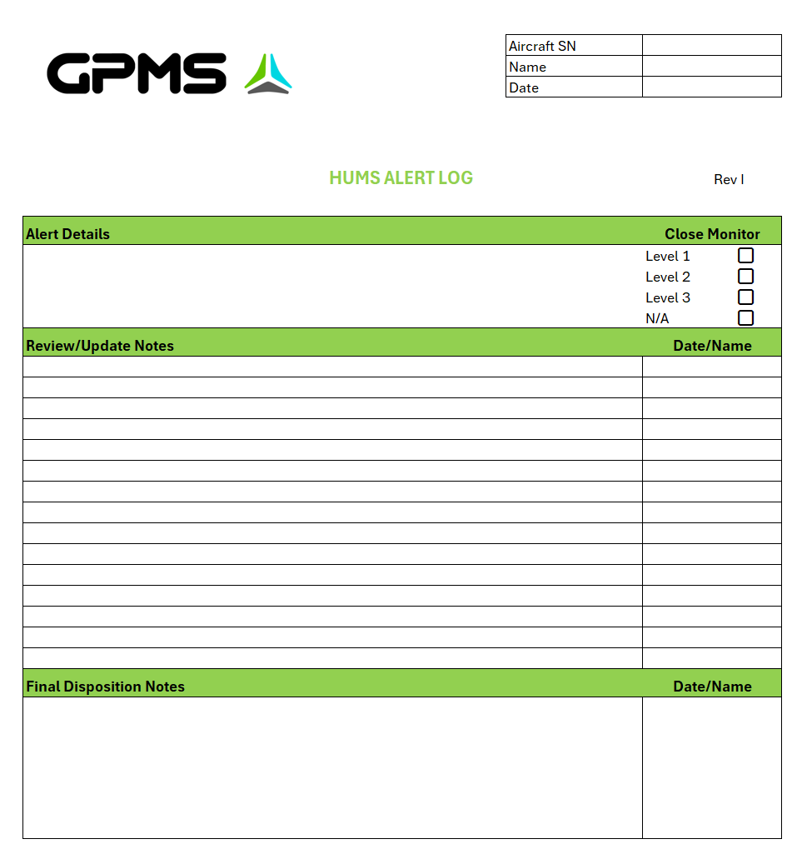

Appendix B

HUMS Action Matrix

 |  | HUMS Action Matrix
 |  | *Validated Findings with Clear Rising Trend
Heavy | Consequence | Repair/Replace | Close Monitor Lvl 3/Position Resources | Close Monitor Lvl 2
Moderate | Consequence | Repair/Replace | Close Monitor Lvl 3/Position Resources | Close Monitor Lvl 2
Minimal | Consequence | Increase Inspection Interval | Increase Inspection Interval | Close Monitor Lvl 1
 |  | Severity
 |  | High | Medium | Low

Failure Mode Index

Indicated Failure Mode | Consequence
Gear Tooth Damage | Heavy
Gear Crack | Heavy
Engine Bearing Degradation | Heavy
FWU Sprag Degradation | Heavy
Main/Tail Gearbox Bearing Degradation | Moderate
Hangar Bearing Degradation | Moderate
Oil Cooler Drive Bearing Degradation | Moderate
Hydraulic Pump Degradation | Moderate
Accessory Drive Degradation | Moderate
Driveshaft Imbalance | Minimal
Driveshaft Misalignment | Minimal
Rotor Imbalance | Minimal

Appendix C

HUMS Flow Chart
Implement program changes/additional maintenance requirements, document, and notify stakeholders.
Document and notify stakeholders.
Yes
Is the alert valid? Ref section 6.3
Covered by HUMS Action Matrix/Failure Mode Index?
Unknown
Notify HUMS provider/OEM. No further actions.
No
Close Monitor Required?
Yes
No
HUMS Steering Committee review.
No
Review at defined interval per sections 6.3, 6.4, 6.5.
Maintenance action required?
Yes
Yes
Perform, document, and notify stakeholders.
No
Contact HUMS provider/OEM for guidance.
HUMS Alert

